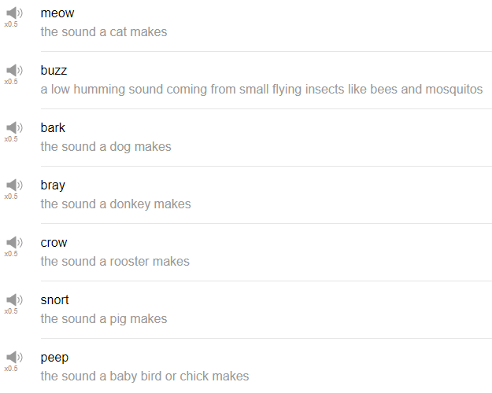

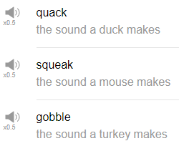

|  |
| --- |
| If a chicken had a favorite composer, it would be Bach, right? Oh my god, do you want to hear a good chicken joke? Oh no, wait! That's not a chicken joke! Why do I think there's a chicken joke? It's not, it's an Arnold Schwarzenegger joke, let's go! |
| Hi, everybody. Welcome back to Top Words. My name is Alisha and today we're going to be talking about 10 animal sounds. So let's go! |
| 1. Buzz |
| This is a word that we use for bees and other small flying creatures, so like maybe mosquitoes buzz, bees buzz, flies buzz, anything small that flies we say, it buzzes. But usually, when you want to replicate the sound, it's buzzz. |
| “A bee in your garden goes buzz.” |
| 2. Meow |
| Meow is the word that is used only for cats, there is no other animal in English to my knowledge that says meow. I think, like, you can extend it to sort of make different cat noises the EO in there, kind of makes a meow sound. That's information that you have now. |
| “I heard my cat meowing in the rain outside this morning and I felt bad because she was cold.” |
| 3. Bark |
| Bark is a word we use for dogs. So there are a couple different kinds of bark though, there's like tree bark as well, but that's different. So a dog's bark is the sound that, like, a dog makes. So we use it as a verb, like “my dog was barking all night last night.” Other words the dog say in English are “bow-wow” and “ruff” and “woof.” These are all dog sounds. |
| 4. Bray |
| Really? Donkeys Bray. This, I don't really use the word bray ever. I don’t think I've ever said “Oh my god, did you hear that donkey braying outside last night, it was so noisy!” But that's beside the point, if you need to, for some reason, explain what sound donkey makes, you can say, the donkey was braying. But if you want to, like, make the same sound as a donkey, for whatever reason, we say, “hee-haw” for donkeys. They are very strange creatures, aren't they? Don't they make a weird sound? “Hee-haw,” braying, that's it. |
| 5. Snort |
| Pigs snort. A snort sound is anything is like that quick air going into your nose. Oh my god, am I gonna snort? I'm not going to snort because I don't want you guys to laugh at me on camera. Snort can be applied to other creatures, like, humans can snort. Maybe like if you have a friend that snorts when he or she laughs you can use the same word. But for pigs, like, to talk about, if like you're reading a children's book for example, it'll usually say the pig says “oink oink,” that's the pig word. |
| 6. Crow |
| Roosters crow, this is a true story “there's a rooster in my neighborhood and it crows in the morning.” I've heard it when I walked past on my way to work, this is a true story. When you're reading children's stories you'll see like the rooster says “cock-a-doodle-doo,” I think that that's like the our attempt at making that… sound into words, like cock-a-doodle-doo! Somehow that's what it's become. Wake up. |
| 7. Peep |
| Chicks make a peep sound. Any baby bird they have, like, such tiny little voices and they're very very fluffy, so like the word we use to describe their voice is peep. It's like that. Such a cute sound. |
| But we use that for chicks, yeah, for baby birds they beep beep beep. This is the beak, by the way, that's what I'm doing my hands. beep beep beep. |
| 8. Quack |
| Ducks are important to me. So ducks quack, we use the word quack to describe a duck. So “lots of ducks quack” on a regular basis. All right quackity quack quack. |
| 9. Squeak |
| Squeak, which we use for mice, mice make a squeak sound, I guess. We're going to youtube it, we're going to YouTube a mouse sound. That sounds like something that you hear in like a horror movie right before like the killer gets the person that's wandering to the haunted house. Huh! I can't replicate that. Oh! |
| 10. Gobble |
| Let's go on to the next word, which is gobble, gobble is only, I feel only used for turkeys, And turkeys are usually only talked about around Thanksgiving, in like November. So turkeys say gobble, gobble gobble gobble. That's the best turkey I can do. Did you ever have to draw turkey when you were in elementary school? Yeah, that's it, with your hand. You put your hand on like the paper and then you make an outline with your hand, then your hand becomes like the Turkey's feathers and then you color it. Yeah, cool, okay. Turkeys gobble. |
| That's the end! So those are ten animal sounds and one of Alisha's stomach sound, did you hear that just now? Great timing stomach. Way to be a team player. |
| Thanks very much for watching this episode of Top Words and we will see you again next time! Bye! |
| What does the dog say? Bark-bark-bark. |
| Oh no, very warm, these lights are killing me today. |